# PRACTICAL-2

**AIM:** Use CrypTool to encrypt and decrypt passwords.

Steps:

1)Install CrypTool from https://[www.cryptool.org/en/ct1-downloads.](http://www.cryptool.org/en/ct1-downloads)

2)Plain Text

3)To Encrypt Click on Encrypt/Decrypt > Symmetric (Classic) > Caesar/ ROT-13

4)Enter Key Entry as Number Value and enter the key. And then click on Encrypt

5)To Decrypt Again click on Encrypt/Decrypt > Symmetric (Classic) > Caesar/ ROT-13. Enter Key Entry as Number Value and enter the key. And then click on decrypt.

# STEPS: (For Caesar Cipher)

1. Install CrypTool from https://[www.cryptool.org/en/ct1-downloads.](http://www.cryptool.org/en/ct1-downloads)
2. Plain Text

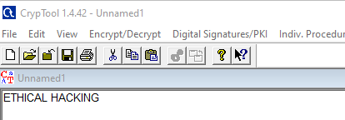

1. To Encrypt Click on Encrypt/Decrypt > Symmetric (Classic) > Caesar/ ROT-13
2. Enter Key Entry as Number Value and enter the key. And then click on Encrypt.

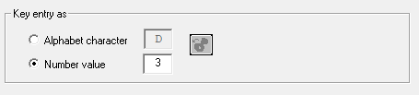

After clicking on Encrypt,

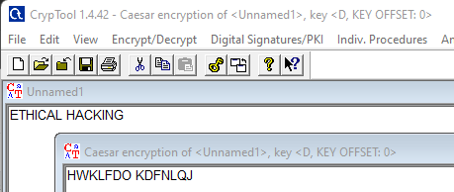

1. To Decrypt Again click on Encrypt/Decrypt > Symmetric (Classic) > Caesar/ ROT-13. Enter Key Entry as Number Value and enter the key. And then click on decrypt.

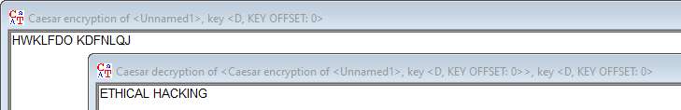

To Encrypt Click on Encrypt/Decrypt > Symmetric (Classic) > Playfair.

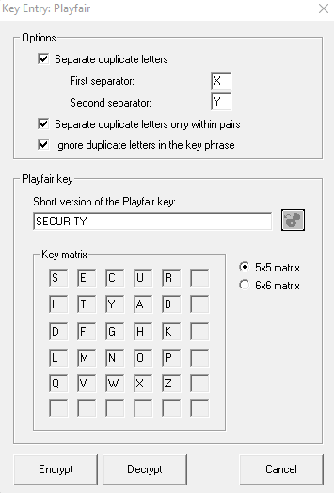

# Cipher Text:

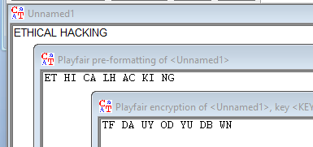

**Plain Text:**

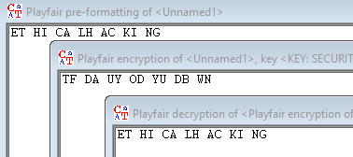

To Encrypt Click on Encrypt/Decrypt > Symmetric (Classic) > Scytale/ Rail Fence.

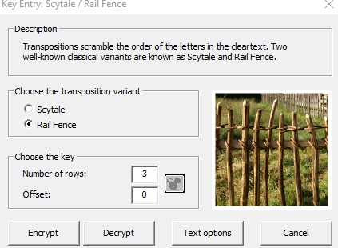

# Cipher Text:

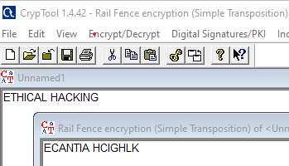

**Plain Text:**

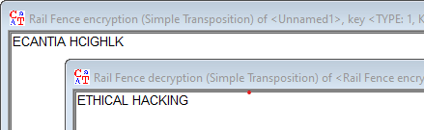

To Encrypt Click on Encrypt/Decrypt > Symmetric (modern) > RC4 Click the number of bits and Encrypt.

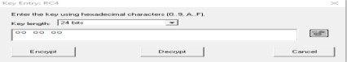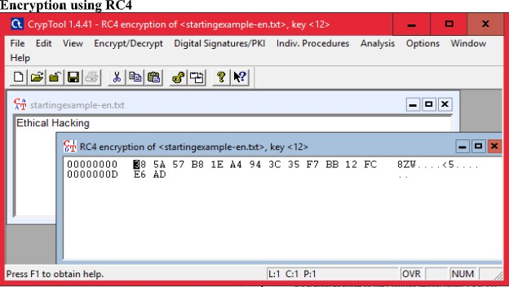

Click the number of bits. And then Decrypt.

